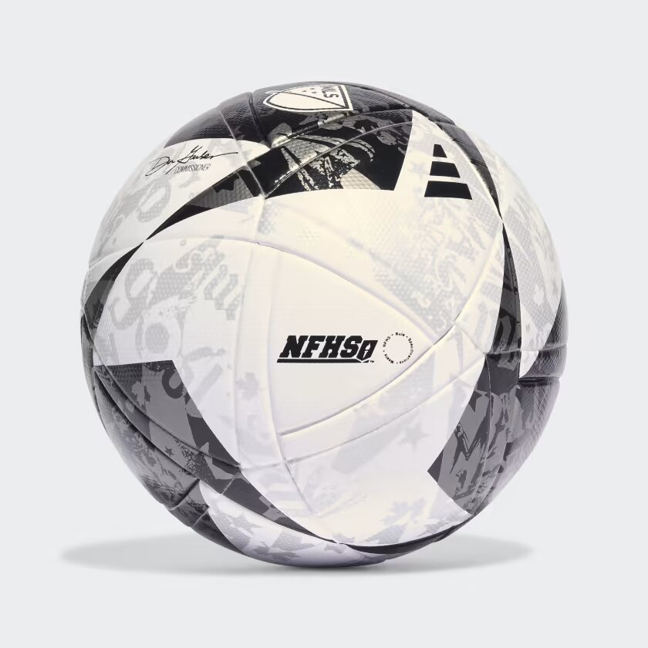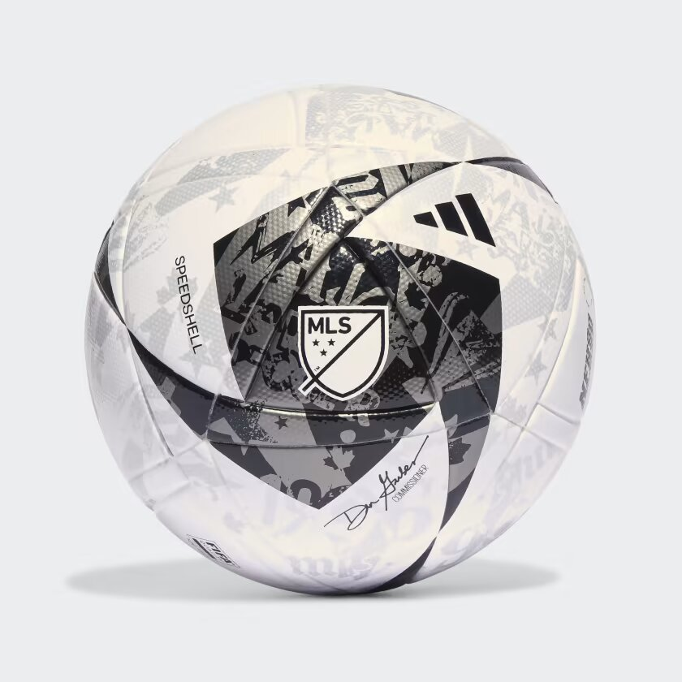

ADIDAS MLS LEAGUE NFHS BALL

**A HIGH-QUALITY TRAINING SOCCER BALL BASED ON THE MLS OFFICIAL MATCH BALL.**

No sporting spectacle can beat soccer fans in full voice. Celebrating the songs and chants that bring MLS stadiums to life, this adidas ball gives off grungy vibes with music poster-inspired graphics. Behind that dynamic design, the seamless TSBE construction and butyl bladder ensure predictability and longevity. A FIFA Quality stamp guarantees it won't miss a beat on the field.

**DETAILS:**

* 100% TPU film
* Butyl Bladder
* Seamless TSBE technology
* FIFA Quality certified
* Requires inflation
* Imported
* Product color: White / Black / Iron Metallic
* Product code: HT9024